Andrew Alferman
MTH 552 Winter '17
Homework #5
Due Wed, February 22, 2017

1.a) The attached code has been modified as directed. A tolerance of approximately 1x10⁻⁴ was needed for the graph to look reasonably correct. Per the figure below, the ODE function for the orbit was called 1182 times in order to create the plot, as counted by the global variable “steps”.

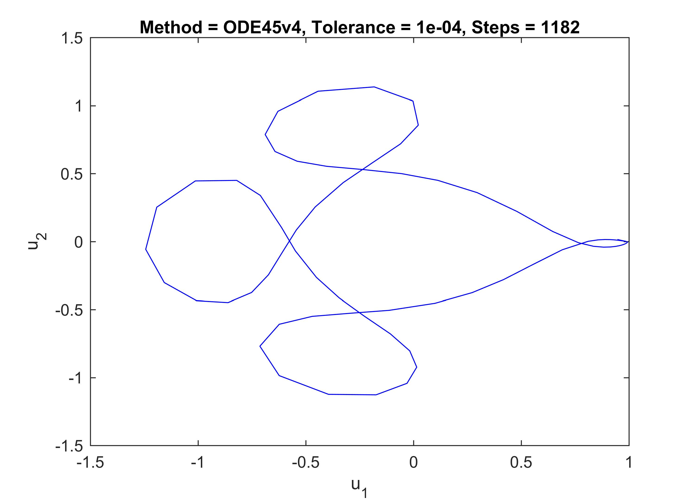

b) The butcher array of the method can be directly found in the ode45v4 code and is repeated below. In this array, the first row of c represents the values for the fifth order accurate formula, and the second row represents the values for the fourth order accurate formula. The method uses the fifth order accurate formula to carry forward the solution, as seen on line 84 of the ode45v4.m file, which reads: y = y + h*f*gamma(:,1); where the 1 is for the first row.

Simple Python code for Problem 2a-2b)

#!/usr/bin/env python3
# -*- coding: utf-8 -*-
"""
Created on Wed Feb 22 20:01:28 2017

@author: alfermaa
"""

import numpy as np

a0 = -3/4
a1 = -1/2
a2 = 1/4
a3 = 1.
b0 = 5/8
b1 = 0.
b2 = 19/8
b3 = 0.

c0 = a0 + a1 + a2 + a3
c1 = -b0 + a1 - b1 + 2*a2 - b2 + 3*a3 - b3
c2 = a1 - 2*b1 + 4*a2 - 4*b2 + 9*a3 - 6*b3
c3 = a1 - 3*b1 + 8*a2 - 12*b2 + 27*a3 - 27*b3
c4 = a1 - 4*b1 + 16*a2 - 32*b2 + 81*a3 - 108*b3

print('c0 = {}'.format(c0))
print('c1 = {}'.format(c1))
print('c2 = {}'.format(c2))
print('c3 = {}'.format(c3))
print('c4 = {}'.format(c4))

coeff = [a3,a2,a1,a0]
roots = np.roots(coeff)
print('Roots: {}'.format(roots))

Example output:
c0 = 0.0
c1 = 0.0
c2 = 0.0
c3 = 0.0
c4 = 8.5
Roots: [ 1.000+0.j -0.625+0.59947894j -0.625-0.59947894j]

2.c) The output of the attached Matlab code can be found below. The value of y at each of the positions of x was computed but is not shown. The error column denotes the L₂-error E_{n}. The results are consistent with the findings in part a). Method 3 had the smallest error at the smallest h value because it was the only convergent method of the three. Method 1 had the largest error as h became smaller because it was not convergent and the results can be interpreted as growing unbounded. Method 2 generally improved in accuracy slightly as h decreased, however the error values were much more consistent across step sizes because it was zeroith order consistent (inconsistent). In most cases with only a few exceptions, the error grew as the computation proceeded because the errors at each step accumulated.

d?) See answer to part c).

